**PRACTICAL-4**

**AIM- Program to demonstrate various kinds of operations that are applied on string.**

1. Program to demonstrate the use of concatenation.
2. Program to retrieve string in normal and reverse order.
3. Program to demonstrate the use of replication operation.
4. Program to demonstrate the use of membership operator (IN and NOT IN).
5. Program to demonstrate the use of relational operator.
6. Program to demonstrate the use of Slice notation.
7. Program to demonstrate the use of Various string function.

1.capitalize()

2.count()

3.endswith()

4.startswith()

5.islower()

6.isupper()

7.lower()

8.upper()

9.find()

10.index()

11.swapcase()

12.lstrip()

13.rstrip()

14.isdigit()

15.isalpha()

16.isalnum()

17.len()

print("1. Program to demonstrate the use of concatenation")

str1='Chandigarh '

str2='University'

print(str1)

print(str2)

con=str1+str2

print(con)

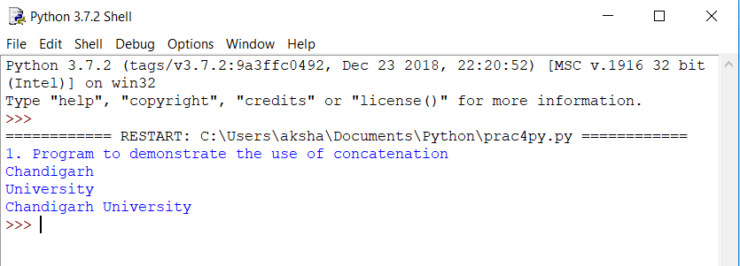

print("2. Program to retrieve string in normal and reverse order")

str3='Akshay'

print(str3)

c=str3[::-1]

print(c)

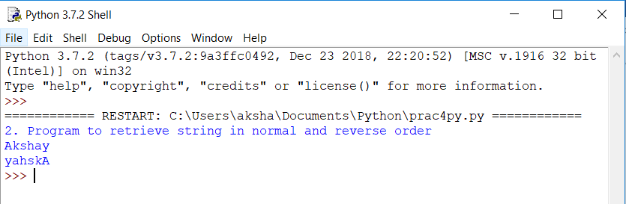

print("3. Program to demonstrate the use of replication operation")

str4=' Akshay '

d=4*str4

print(d)

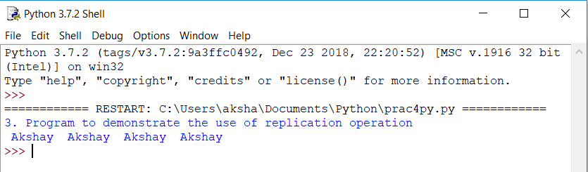

print("4. Program to demonstrate the use of membership operator (IN and NOT IN)")

str5='Chandigarh'

str6='university'

t=str6 not in str5

print(t)

str5='Chandigarh'

str6='university'

t=str6 in str5

print(t)

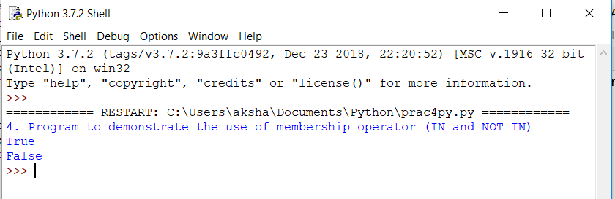

print("5. Program to demonstrate the use of relational operator")

str7='Akshay'

str8='Akshayy'

y=str7>str8

u=str7<str8

print(y)

print(u)

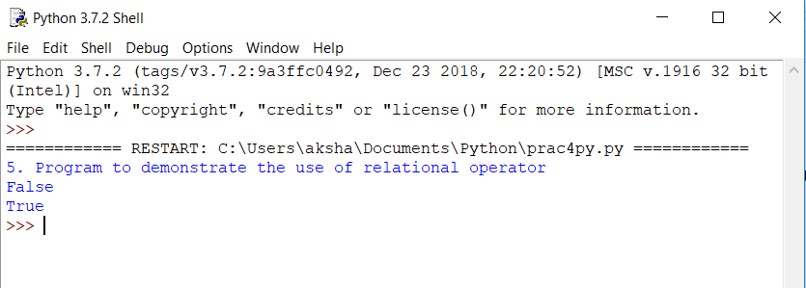

print("6. Program to demonstrate the use of Slice notation")

str9='Chandigarh University'

print(str9)

o=str9[3:9]

print(o)

str9='Chandigarh University'

print(str9)

o=str9[7:9]

print(o)

str9='Chandigarh University'

print(str9)

o=str9[:5]

print(o)

str9='Chandigarh University'

print(str9)

o=str9[3:]

print(o)

str10='Akshay'

print(str10)

p=str10[-1:-5:-4]

print(p)

print()

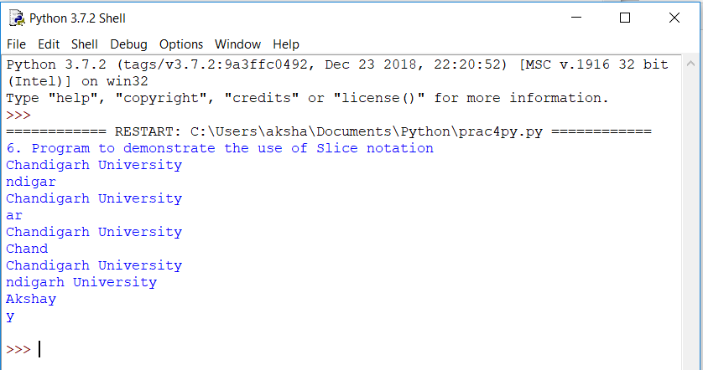

print("7. Program to demonstrate the use of Various string function")

print("capitalize()")

strr='akshay Jawla'

i=strr.capitalize()

print(i)

print("count()")

strr='akshay'

strrr='a'

i=strr.count(strrr)

print(i)

print("endswith()")

strr='akshay'

strrr='y'

i=strr.endswith(strrr)

print(i)

print("startswith()")

strr='akshay'

strrr='y'

i=strr.startswith(strrr)

print(i)

print("islower()")

strr='akshay jawla'

i=strr.islower()

print(i)

print("isupper()")

strr='AKSHAY JAWLA'

i=strr.isupper()

print(i)

print("lower()")

strr='AKSHAY JAWLA'

i=strr.lower()

print(i)

print("upper()")

strr='akshay jawla'

i=strr.upper()

print(i)

print("find()")

strr='akshay'

strrr='y'

i=strr.find(strrr)

print(i)

print("index()")

strr='akshay'

strrr='k'

i=strr.index(strrr)

print(i)

strr='akshay'

i=strr.index('a',4,5)

print(i)

print("swapcase()")

strr='AksHay jAwLa'

i=strr.swapcase()

print(i)

print("lstrip()")

strr=' akshay'

i=strr.lstrip()

print(i)

print("rstrip()")

strr='akshay '

i=strr.rstrip()

print(i)

print("isdigit()")

strr='Akshay2774'

i=strr.isdigit()

print(i)

print("isalpha()")

strr='Akshay2774'

i=strr.isalpha()

print(i)

print("isalnum()")

strr='Akshay2774'

i=strr.isalnum()

print(i)

print("len()")

strr='AkshayJawla'

i=len(strr)

print(i)

